UML Design Modeling

Selina Rodriguez

CST499: Capstone for Computer Software Technology

Instructor: Amr Elchouemi

January 25, 2021

Class Diagram

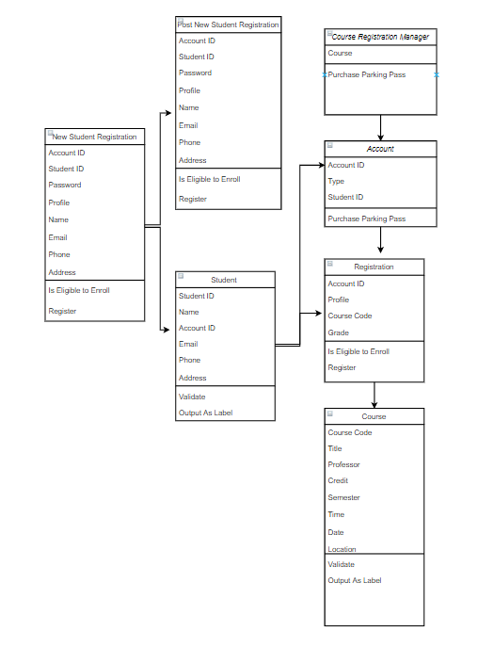

Use Case Diagram

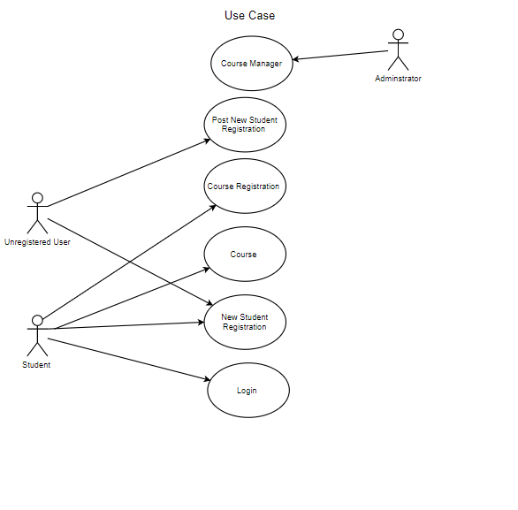

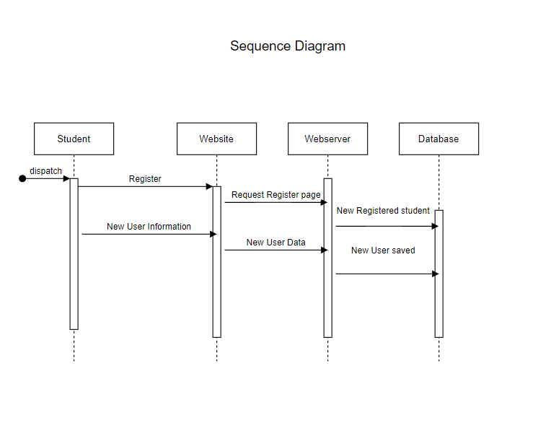

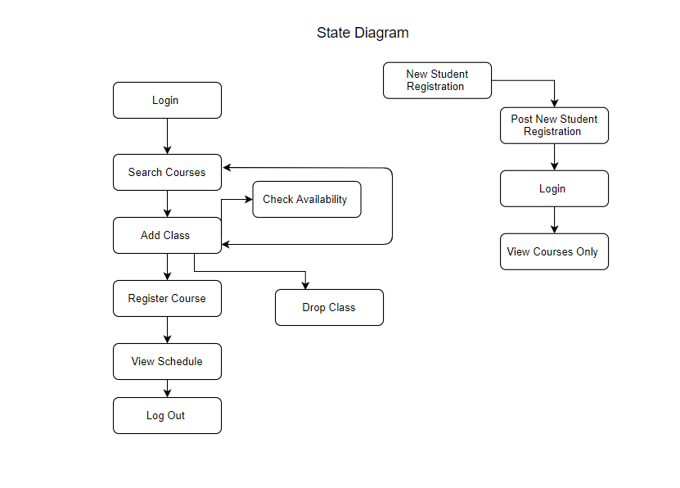

Component Testing is the step that defines each subsystem, including its task, behavior, inner structure, and interfaces to other subsystems (Spillner &. et al., 2014).

Integration Testing is the phase of integration testing the phase is in charge of testing groups of components making sure that they are interacting as they should be by the technical system design making sure they all coordinate and perform together as one.

System Testing phase is testing the system as a whole making sure it meets the key requirements. The system testing makes sure all the functionality and communication meet the

requirements and if changes need to be made this is the phase to find the errors.

Acceptance Testing phase will validate if the system meets the customer requirements this phase will make sure it has met all the requirements to be able to be delivered to the customer. The system is ready to be used by the customer and has been developed to do what the customer intends the product to do.

Spillner, A., Linz, T., & Schaefer, H. (2014). Software testing foundations: A study guide for the certified tester exam (4th ed.). Rocky Nook.

References:

Ingeno, J. (2018). Software architect’s handbook: Become a successful software architect by implementing effective architecture concepts. Retrieved from https://www.vitalsource.com/

Peter Morlion CORE ·, Morlion, P., 30, J., Like (151) Comment (17), &amp; Like (151) Comment (17). (2018, June 30). Software Architecture: The 5 Patterns You Need to Know - DZone Microservices. Retrieved August 11, 2020, from https://dzone.com/articles/software-architecture-the-5-patterns-you-need-to-k